Chapter 13 Exploring the final frontier
Short investigation 13.3: Balloon rockets
Name:
Aim
To examine demonstrate some basic rocket design ideas
Materials
4 party balloons, several drinking straws, several sheets of paper
Theory
We all know that if you inflate a balloon and let it go, it will zoom around the room randomly before running out of air. This is an example of the sort of force pair that drives a rocket: the balloon exerts a force on the air pushing it backwards, and in return the air exerts a force on the balloon pushing it forwards. Unfortunately, the motion is too random to be useful, but there are strategies that can be employed to straighten up the balloon’s flight. Some of these ideas are quite old, having been first used by people such as Robert Goddard over a hundred years ago.
Method
Note that this activity is best performed outdoors on a windless day, using ordinary party balloons. As you construct the balloon rockets, remember that weight will reduce its performance, so use as little tape as possible.
- First inflate a balloon, point it at the sky and let it go. Observe and then describe its motion.
- The next step is to add a guide-stick to a balloon. Join four straws together. Inflate a new balloon and then tape the top of the guide-stick to the side of the balloon. Refer to the figure. Aim this balloon at the sky as before and let it go, observing its motion. How does the motion of this balloon compare to the first balloon?
Suggested further investigation: How does the number of straws used to make the guide-stick affect the balloon’s motion?
- Fins can be added to the guide stick. To do this you need a square piece of paper that can be folded as shown in the figure. Reduce the guide-stick to three straws and attach the paper fins to the guide-stick as shown. This moves the centre of drag back behind the centre of mass. Once again, inflate a new balloon, attach the guide-stick, aim it at the sky and let it go. Describe the motion of the balloon rocket this time.
Suggested further investigation: How does the size of the fins affect their performance?
- The balloon rocket’s flight can be further straightened by making it spin, since rotating objects tend to maintain the direction of their axis of rotation, just as a gyroscope does. This can be achieved by folding each fin slightly as shown in the diagram. Do not make these folds too large or too sharp as they can add significant drag (enough to prevent lift-off completely!). Inflate a new balloon and attach your guide-stick and fin assembly to the side of it. Launch this balloon rocket as before and describe what you observe.
Suggested further investigation: How small can the fin deflection be in order to achieve its effect?
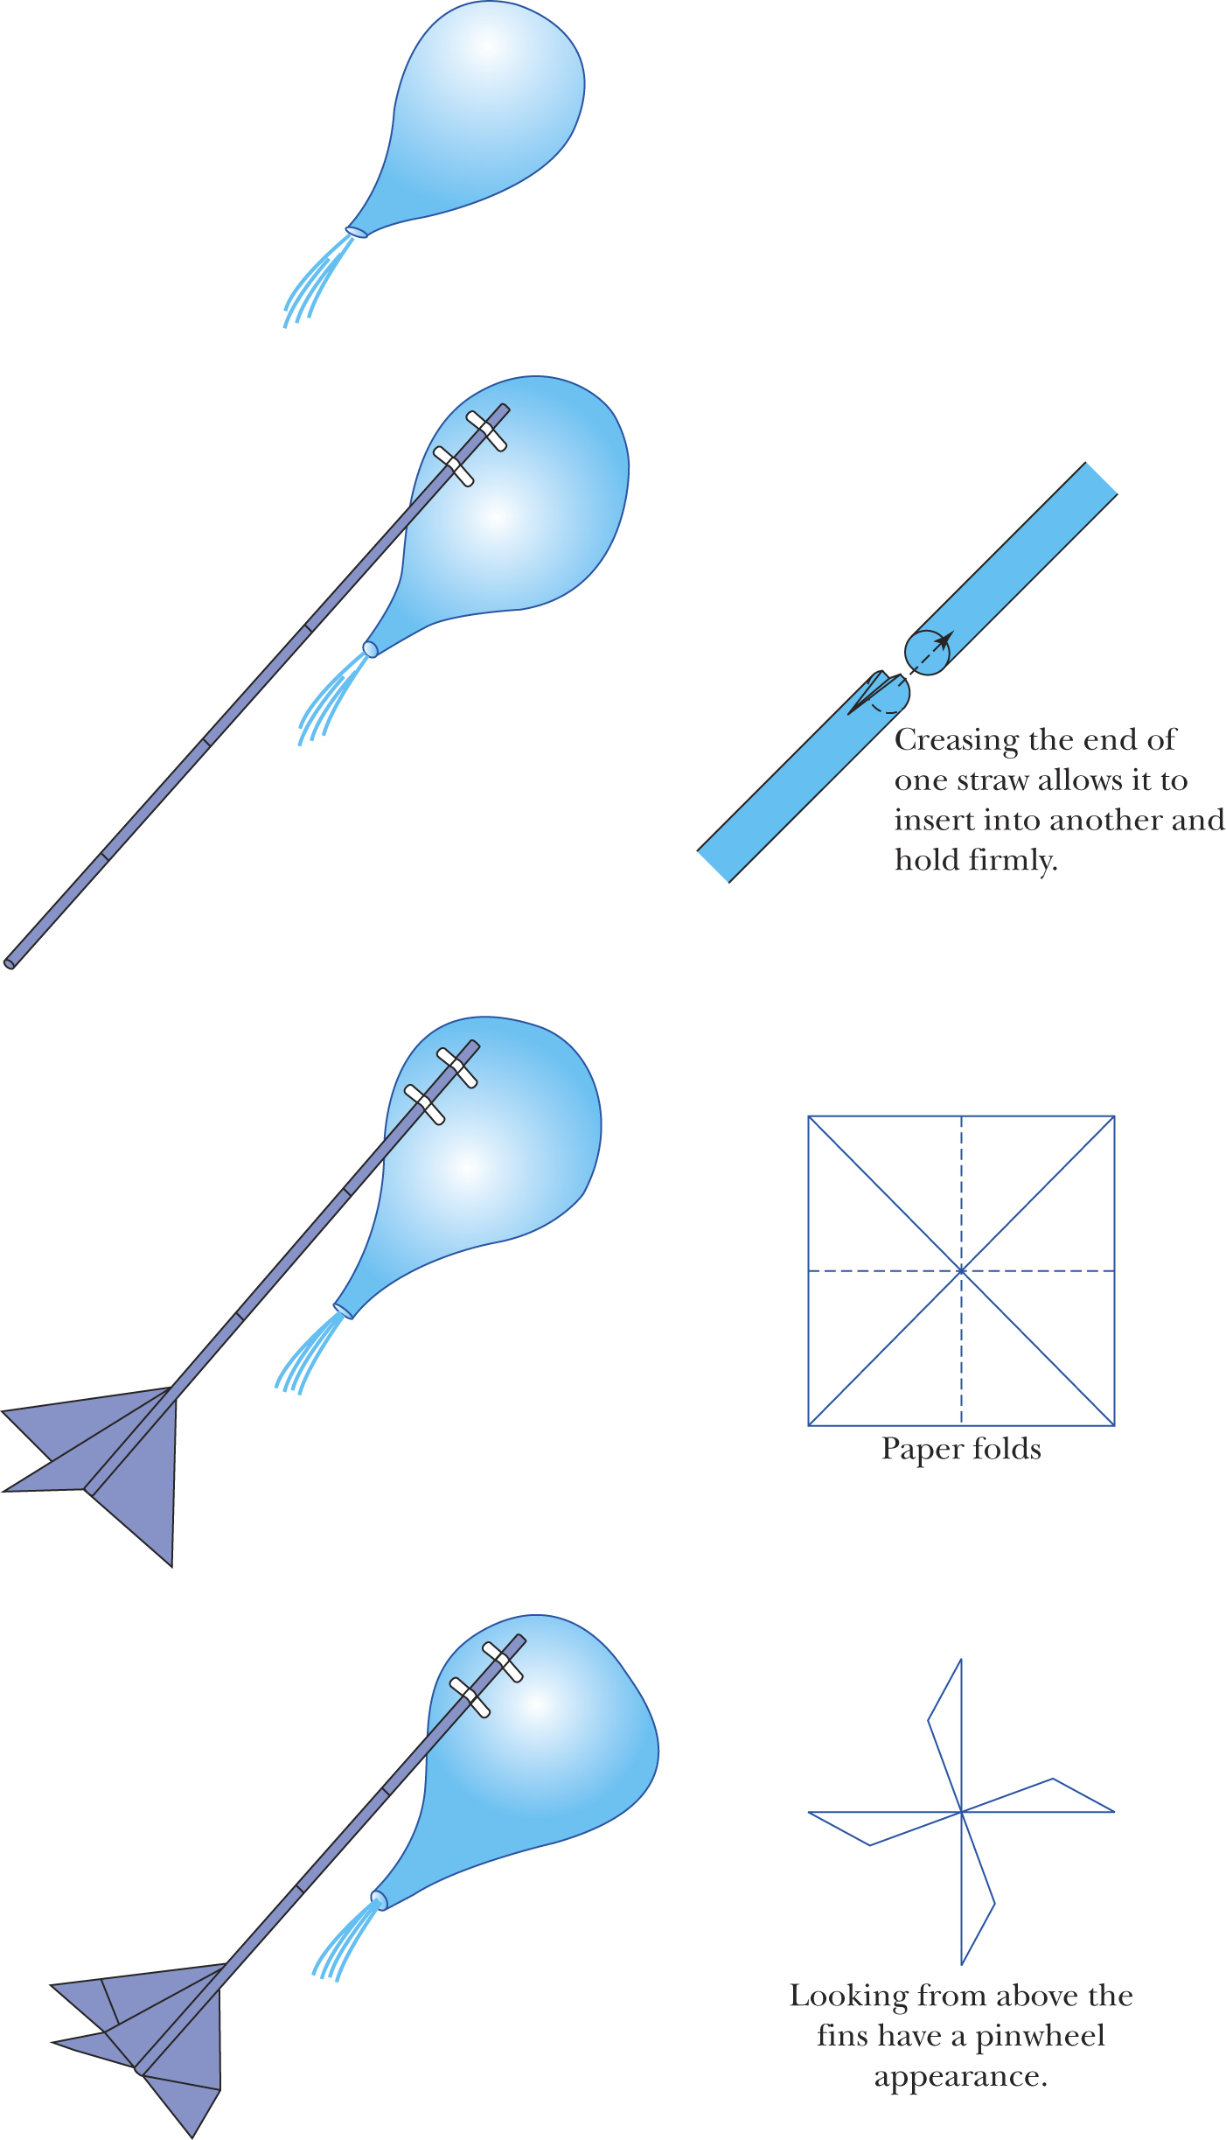
Internet research
Access the internet to research how the stability of a rocket depends on the location of the centre of drag, the centre of mass and the centre of thrust. Describe examples of how these ideas apply to modern rockets.
Notes:

